|  | INTERNATIONAL TELECOMMUNICATION UNION  **TELECOMMUNICATION** **STANDARDIZATION SECTOR**  STUDY PERIOD 2022-2024 | | **Focus Group on AI Native Networks** | |
| --- | --- | --- | --- | --- |
| **AINN-I-xx** | |
| **Original: English** | |
| **Question(s):** | | N/A | Virtual, TBD 2024 | |
| **INPUT DOCUMENT** | | | | |
| **Source:** | | *Team Bangalore* | | |
| **Title:** | | *Team Bangalore* *- Report on* *ITU WTSA Hackathon 2024 – Connected Car* | | |
| **Contact:** | | Mr. Ramesh | | E-mail: name@gmail.com |

| **Abstract:** | This document contains the submission of report for *Team Bangalore* towards ITU WTSA Hackathon 2024 for use case Connected Car |
| --- | --- |

## Use case introduction: **“Connected Car”**

In the city of New Delhi, a new era of driving was about to begin. A cutting-edge connected car service named: StreetHawk was launched, promising to transform the way people navigated the city’s streets. With each phase, the service adapted to the city's unique challenges, setting a new standard for urban mobility.

Consider the scene map below:

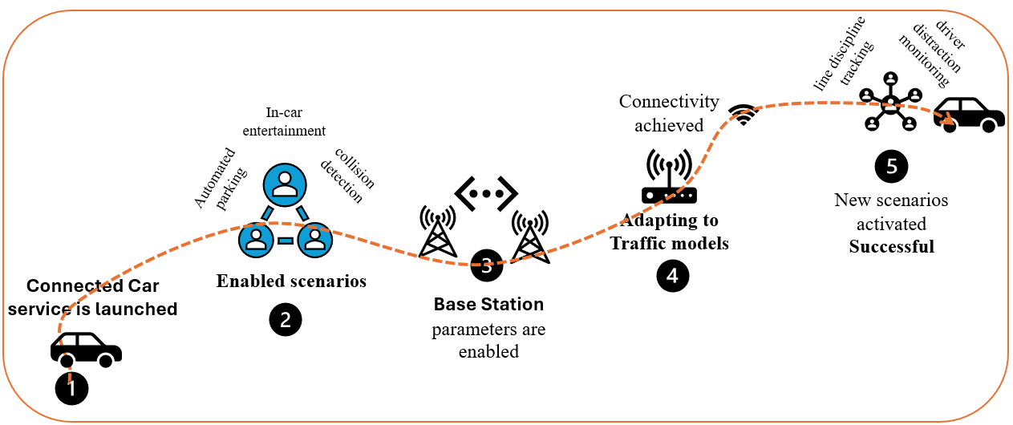

Phase 1: New connected car service is launched in New Delhi

Phase 2: Automated Parking, in-car entertainment, collision detection these scenarios are enabled 1 by 1.

Phase 3: Based on the location of the vehicles, base station parameters are enabled for this scenario.

Phase 4: Adapting to Traffic Models

Phase 5: New scenarios are activated such as: line discipline tracking, driver distraction monitoring.

Clause-2: use case requirements

Clause-3: PS1: pipeline design

* AI /ML Concept used is proximity detection, resource prediction and anomaly detection

Clause-4: PS2: xApp design

* Open RAN concept used is scaling and fitting base station power parameters, and adapting to traffic models

Clause-5: Relation to Standards.

Clause-6: Code submission details

Clause-7: Self-Testing results

_________________